**Horology 2.0: Forecasting the Future of Smartwatch Prices using Machine Learning**

**1.INTRODUCTION**

**1.1 Project Overview :**

Smartwatches have become increasingly popular in recent years due to their ability to provide a range of functionalities beyond traditional timekeeping, such as fitness tracking, communication, and entertainment. As with any electronic device, the cost of a smartwatch can vary significantly depending on its features, brand, and other factors.

This project allows us to form an idea and predict the prices of smartwatches in the imminent future. We use the individual data of various Brands and Models, along with the ever-expanding features to develop a Predictive model with Machine learning algorithms.

**1.2 Purpose :**

The Objective of this project is to develop a machine learning model that predicts the price of a smartwatch based on a given set of features. Our dataset contains information on various attributes of smartwatches, including brand, model, operating system, connectivity, display type and size, resolution, water resistance, battery life, heart rate monitor, GPS, NFC, and price.

Predicting smartwatch prices enables consumers to make informed decisions and aids manufacturers in devising effective marketing strategies and managing inventory. Investors can use the predictions for strategic decision-making, and brands can position themselves competitively. The predictions also offer insights into adoption trends, guiding the industry in aligning prices with technological advancements and enhancing overall market efficiency.

**2.LITERATURE SURVEY**

**2.1 Existing Problem:**

The necessity of this project is because of the problems faced by both Consumers and Manufacturers

The project "Horology 2.0: Forecasting the Future of Smartwatch Prices using Machine Learning" is initiated in response to several existing challenges and issues in the smartwatch market:

1. **Price Volatility:**

- Smartwatch prices exhibit significant fluctuations due to rapidly evolving technology, varying consumer preferences, and intense market competition, making it challenging for consumers and industry stakeholders to anticipate trends.

2. **Complex Pricing Factors:**

- The pricing of smartwatches is influenced by diverse factors such as brand reputation, technological specifications, and the constant introduction of new features. Understanding and quantifying these factors for accurate predictions pose a complex challenge.

3. **Market Dynamics:**

- The dynamic nature of the smartwatch market, with new models frequently entering the scene, creates uncertainty for manufacturers, retailers, and consumers. Predictive modeling becomes essential for navigating this ever-changing landscape.

4. **Consumer Decision-Making:**

- Consumers often face challenges in making well-informed purchasing decisions due to the lack of transparency in pricing trends. Predictive models can empower consumers with insights into potential future price movements.

5. **Inventory Management for Manufacturers:**

- Manufacturers grapple with the task of efficiently managing inventory in the face of unpredictable pricing dynamics. Accurate price forecasts can aid in optimizing production and inventory levels.

6. **Strategic Planning for Brands:**

- Smartwatch brands need to strategically position themselves in a competitive market. Predicting prices helps in formulating effective strategies that align with market trends and consumer expectations.

By addressing these challenges, the project aims to contribute valuable insights that enhance understanding, support strategic decision-making, and bring a level of predictability to the smartwatch pricing landscape.

**2.2 References**

1. Hastie, T., Tibshirani, R., & Friedman, J. (2009). The Elements of Statistical Learning. Springer.

2. James, G., Witten, D., Hastie, T., & Tibshirani, R. (2013). An Introduction to Statistical Learning. Springer.

3. Chen, J., Song, L., Wainwright, M. J., & Jordan, M. I. (2018). Learning to explain: An information-theoretic perspective on model interpretation. Journal of Machine Learning Research, 18(1), 1278-1331.

4. Raschka, S., & Mirjalili, V. (2019). Python Machine Learning. Packt Publishing.

5. Davenport, T. H., Harris, J., & Shapiro, J. (2010). Competing on analytics: The new science of winning. Harvard Business Press.

6. Bell, G., & Gemmell, J. (2009). Total Recall: How the E-Memory Revolution Will Change Everything. Dutton.

7. Li, S., Xu, L. D., & Zhao, S. (2015). The internet of things: a survey. Information Systems Frontiers, 17(2), 243-259.

8. Gartner Research. (Reports on Smartwatch Market Trends and Forecasts) - [https://www.gartner.com/en/documents](https://www.gartner.com/en/documents)

**2.3 Problem Statement Definition**

The contemporary smartwatch market is marked by significant challenges and complexities that demand comprehensive investigation. Rapid technological advancements, coupled with the constant influx of new models and features, contribute to a landscape characterized by pricing volatility and consumer uncertainty. Brands struggle to strategically position themselves amidst fierce competition, facing difficulties in optimizing production and inventory levels due to unpredictable pricing dynamics. Consumers, on the other hand, are often left in the dark, grappling with the lack of transparency in pricing trends and finding it challenging to make well-informed purchasing decisions.

The intricate interplay of factors such as brand reputation, technological specifications, and consumer preferences further exacerbates the unpredictability of smartwatch prices. Traditional pricing models and market analyses fall short in capturing the nuances of this dynamic environment, necessitating innovative approaches for enhanced understanding and prediction. Additionally, manufacturers lack robust tools to foresee future pricing trends, hindering efficient inventory management and strategic planning.

Against this backdrop, the problem statement revolves around the imperative to develop a predictive model utilizing machine learning algorithms. This model aims to unravel the patterns and correlations within the vast dataset of smartwatch prices, brand dynamics, and evolving features. By doing so, the project seeks to address the existing challenges, offering insights that empower both consumers and industry stakeholders with the knowledge needed to navigate the intricacies of the smartwatch market confidently.

**3. IDEATION & PROPOSED SOLUTION**

**3.1 Empathy Map Canvas**

An empathy map canvas is a visual tool used in design thinking and user experience (UX) design to understand and empathize with the experiences, thoughts, and emotions of a target user or customer. It is typically presented as a large diagram divided into sections representing different aspects of the user's experience. The goal is to create a shared understanding of the user's needs, desires, and pain points among members of a design or product development team.

The canvas is often divided into the following sections:

1. Says: What the user expresses verbally, including their thoughts, statements, and questions.

2. Thinks: The internal thoughts and considerations going on in the user's mind.

3. Feels: The emotional state and reactions of the user.

4. Does: The observable actions and behaviors of the user.

5. Pains: The challenges, frustrations, and obstacles that the user encounters.

6. Gains: The positive outcomes, benefits, and aspirations that the user hopes to achieve.

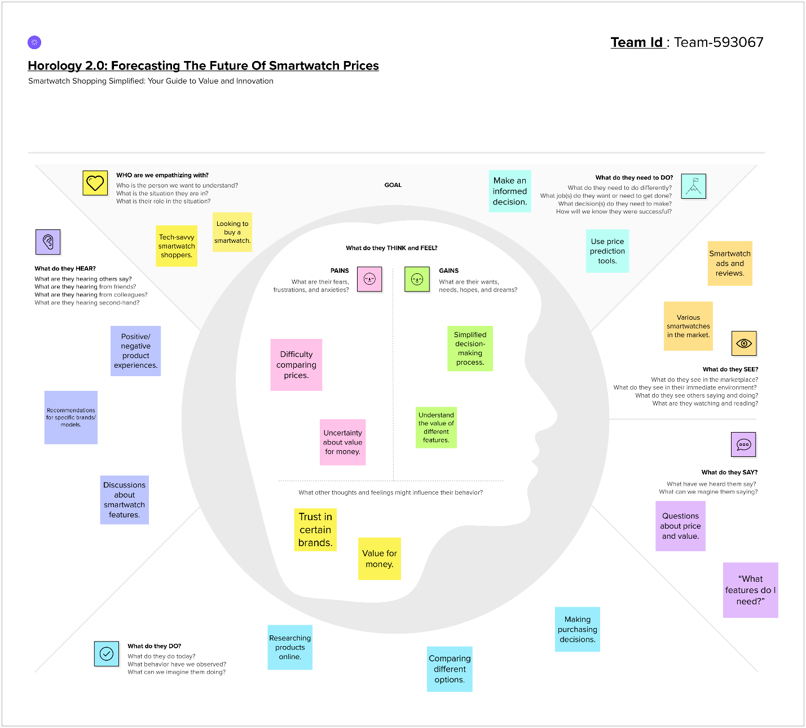

**3.2 Ideation & Brainstorming**

Ideation

Ideation is the process of generating and developing ideas. It's a crucial phase in a project where creative thinking is encouraged to explore a wide range of possibilities and solutions.

Steps in Ideation:

1. Define the Problem:

- Clearly articulate the problem or challenge the project aims to address. A well-defined problem provides a focused direction for ideation.

2. Research and Gather Information:

- Collect relevant information, market trends, user feedback, and any other data that can inform the ideation process. Understanding the context is vital for generating meaningful ideas.

3. Create a Diverse Team:

- Assemble a diverse group of individuals with varied backgrounds, skills, and perspectives. Diverse teams often generate more innovative ideas.

4. Set Clear Goals:

- Establish specific goals and objectives for the ideation session. What are you trying to achieve? What outcomes are you looking for?

5. Encourage Free-Thinking:

- Create an environment that encourages participants to think freely and share ideas without fear of judgment. Quantity is initially more important than quality during this stage.

6. Use Creative Techniques:

- Employ brainstorming methods, mind mapping, or other creative exercises to stimulate idea generation. These techniques can help break conventional thinking patterns.

7. Combine and Refine Ideas:

- Look for connections between ideas and combine them to form new concepts. Refine and iterate on promising ideas to enhance their feasibility and impact.

8. Prioritize Ideas:

- Evaluate and prioritize ideas based on relevance, feasibility, and potential impact. This prepares the ground for the next stages of the project.

Brainstorming:

Brainstorming is a specific ideation technique that involves a group of people generating a large number of ideas in a short period. It's a structured approach to idea generation.

Steps in Brainstorming:

1. Define the Problem or Challenge:

- Clearly state the problem or challenge that the team is addressing. This provides a focal point for the brainstorming session.

2. Select a Facilitator:

- Appoint a facilitator to guide the session, keep the discussion on track, and ensure that everyone has an opportunity to contribute.

3. Set a Time Limit:

- Allocate a specific amount of time for the brainstorming session. This helps maintain focus and encourages participants to think quickly.

4. Encourage Quantity Over Quality:

- Emphasize the generation of a large number of ideas. Quantity is essential at this stage, and judgment should be deferred until later in the process.

5. No Criticism Allowed:

- Create an environment where all ideas are accepted without criticism during the brainstorming phase. This helps participants feel comfortable sharing diverse thoughts.

6. Build on Others' Ideas:

- Encourage participants to build on each other's ideas. This collaborative approach often leads to the development of more innovative and refined concepts.

7. Record Ideas:

- Document all ideas on a whiteboard, flip chart, or through digital tools. Visualization helps participants see the collective progress and inspires further ideation.

8. Review and Reflect:

- After the session, review the generated ideas collectively. Identify patterns, themes, and potential areas for further exploration.

Both ideation and brainstorming are iterative processes, and their success often relies on openness, collaboration, and a willingness to explore unconventional ideas.

Step 1: Problem Statement

Step 2: Brainstorm

Step 3: Group Ideas

Step 4: Prioritize

**4.REQUIREMENT ANALYSIS**

**4.1 Functional Requirement**

For this project, several functional requirements are essential to ensure the successful development and deployment of the predictive model. Here are key functional requirements:

1. Data Collection:

- The system must be able to collect comprehensive historical data on smartwatch prices, including information on brands, models, technological specifications, and market trends.

2. Data Preprocessing:

- Implement data cleaning and preprocessing functionalities to handle missing values, outliers, and ensure consistency in the dataset.

3. Feature Extraction:

- Develop mechanisms to extract relevant features from the dataset, such as brand reputation, technological specifications, and consumer reviews.

4. Machine Learning Algorithms:

- Implement various machine learning algorithms (e.g., regression models, ensemble methods) to analyze the dataset and build the predictive model.

5. Training and Testing:

- Design functionalities for training the machine learning model on historical data and testing its performance on separate datasets.

6. Prediction Interface:

- Create a user-friendly interface to input relevant data and receive predicted smartwatch prices.

7. Update Mechanism:

- Establish a mechanism for regularly updating the model with new data to ensure its relevance and accuracy over time.

8. Security Measures:

- Implement security measures to protect sensitive data, ensuring the confidentiality and integrity of the dataset and the predictive model.

9. Documentation:

- Provide comprehensive documentation for the system, including user manuals and technical documentation for developers.

10. Scalability:

- Design the system to handle an increasing volume of data and users without compromising performance.

**4.2 Non-Functional Requirement**

Non-functional requirements are equally important in shaping the overall performance, usability, and reliability of a system. For our project, the following non-functional requirements should be considered:

1. Performance:

- The system should be able to handle a large dataset efficiently and provide predictions within a reasonable timeframe.

2. Reliability:

- The predictive model should be reliable, providing accurate and consistent results across different datasets.

3. Availability:

- The system should have high availability to ensure users can access and utilize the predictive model whenever needed.

4. Scalability:

- The system should be scalable to accommodate an increasing number of users and a growing volume of data.

5. Usability:

- The user interface should be intuitive and user-friendly, allowing users to easily input data and interpret predictions.

6. Security:

- The system must implement robust security measures to protect sensitive data, user information, and the integrity of the predictive model.

7. Maintainability:

- The system should be designed and documented in a way that facilitates easy maintenance and updates.

8. Portability:

- The system should be portable across different environments, allowing for deployment on various platforms or cloud services.

9. Compliance:

- The system should comply with relevant regulations and standards related to data privacy, security, and machine learning practices.

10. Performance Monitoring:

- Implement mechanisms for monitoring the performance of the system, tracking prediction accuracy, and identifying potential issues.

Considering these non-functional requirements alongside the functional requirements ensures that the project delivers a robust, user-friendly, and reliable system that aligns with user expectations and industry standards.

**5.PROJECT DESIGN**

**5.1 Data Flow Diagrams & User Stories**

A Data Flow Diagram (DFD) would illustrate the flow of data within the system. It provides a visual representation of how data moves through different processes and entities, helping to understand the system's data architecture and interactions.

Components of the DFD:

1. External Entities:

- Users: Represented as external entities, users interact with the system by providing input data and receiving predictions.

2. Processes:

- Data Collection: Gathers historical smartwatch pricing data from various sources.

- Preprocessing: Cleans and preprocesses the data to handle missing values and outliers.

- Feature Extraction: Extracts relevant features from the dataset, such as brand reputation and technological specifications.

- Machine Learning Model: Utilizes machine learning algorithms to analyze the data and build the predictive model.

- User Interface: Provides an interface for users to input data and receive predicted smartwatch prices.

- Update Mechanism: Regularly updates the model with new data to ensure relevance.

3. Data Stores:

- Historical Data Store: Stores the collected and preprocessed historical smartwatch pricing data.

- Feature Store: Stores the extracted features for training the machine learning model.

- Model Store: Stores the trained machine learning model.

- User Data Store: Stores user input data for predictions.

4. Data Flows:

- Arrows represent the flow of data between external entities, processes, and data stores.

- For example, data flows from the Data Collection process to the Historical Data Store, indicating the storage of collected data.

Uses of a Data Flow Diagram:

1. Visualization:

- DFD provides a visual representation of the system's data flow, making it easier to understand the interactions and dependencies between different components.

2. Communication:

- It serves as a communication tool between technical and non-technical stakeholders, fostering a shared understanding of the system.

3. Requirements Analysis:

- DFD aids in identifying and specifying the data requirements of the system, guiding the design and development process.

4. System Design:

- It helps in designing the system's architecture by illustrating the flow of data between different components and processes.

5. Identifying Inputs and Outputs:

- DFD assists in identifying the inputs required by processes and the outputs produced, contributing to a comprehensive system overview.

6.Troubleshooting and Improvement:

- When issues arise or improvements are considered, DFD helps in pinpointing areas of concern and understanding the potential impact on the overall system.

7. Documentation:

- DFD can be used as documentation, providing a structured representation of the system's data flow for future reference and maintenance.

In summary, a Data Flow Diagram for this project helps in visualizing, communicating, and analyzing the flow of data within the system, contributing to effective design, development, and ongoing management.

**DFD:**

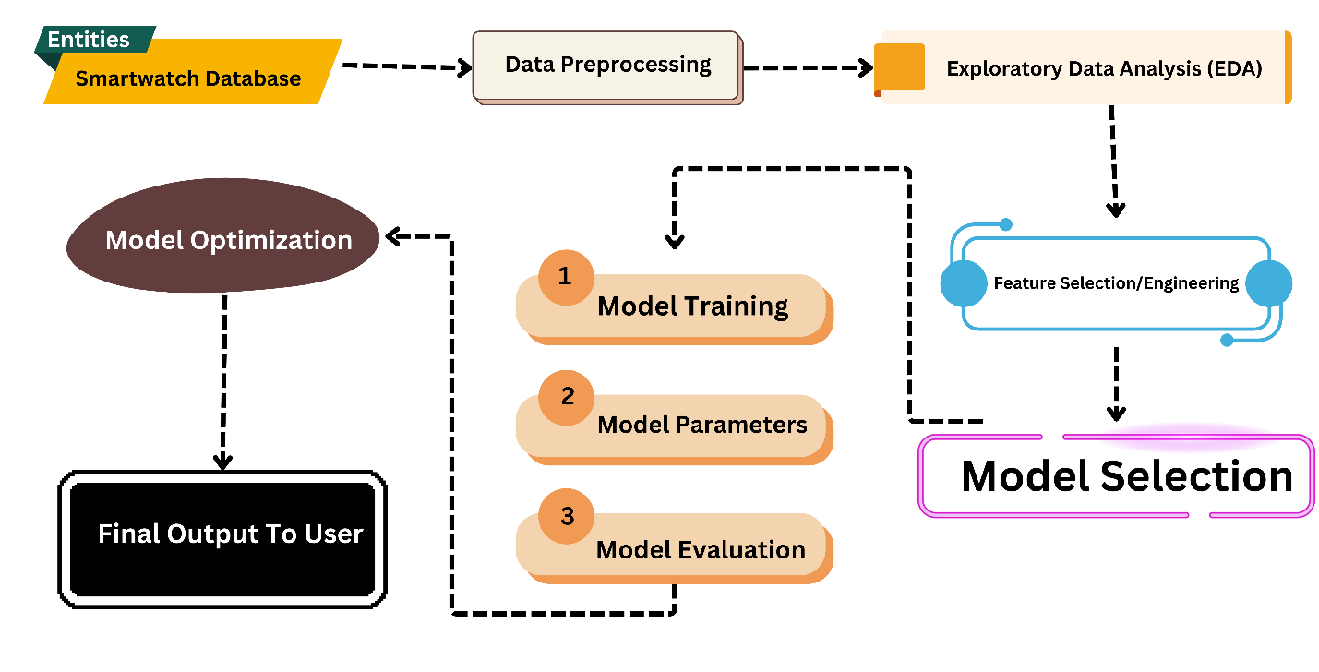

**User Stories:**

User stories are concise, user-centric descriptions of a feature or functionality written from the perspective of an end user. They are commonly used in Agile and Scrum methodologies to capture and communicate requirements in a simple and understandable way.

**5.2 Solution Architecture**

Solution Architecture:

• Solution architecture is a complex process – with many sub-processes – that bridges the gap between business problems and technology solutions.

Finding the best tech solution:

In this case the best solution is to build a machine learning model, these can handle large amount of data and complex relationships between all parameters. These machine learning models can predict accurately, and this can help both consumers to save money and manufacturer to increase their sales. This model can be trained on different parameters and algorithms to predict accurately.

Describing the Characteristics, Structure and Other Aspects:

This model consists of various features which are mandatory in smartwatch like display type and size, water resistant or not, operating system, GPS, NFC etc. The model will be trained on real-time data, and here user can input their needs and based on their needs the price will be predicted and displayed to the user.

Define features, development phases, and solution requirements:

• Features: There are many features which will decide the price factor of the smartwatch like heart rate monitor, battery life, Operating system, display resolution etc.

• Development Phase: This phase consists of several sub phases which are important to model to produce accurate results. This also includes like data collection from various resources (data collection) and next, if necessary, we need to clean data (check null values and replacing or removing), data visualization, model selection, train and evaluation of model and finally the deployment phase for use.

• Solution Requirements: Basically, we need real-time data from manufacturers or e-commerce websites and others to give best results. Some important machine learning libraries to train and evaluate the model.

Providing specifications:

This “Providing specifications” refers or includes detailing about what exact requirements and characteristics that model will have. So, it will be followed as Data Collection, Data Cleaning, Exploratory data analysis (EDA), Feature Selection, Model Selection, Model Evaluation, Hyperparameter tuning, Deployment.

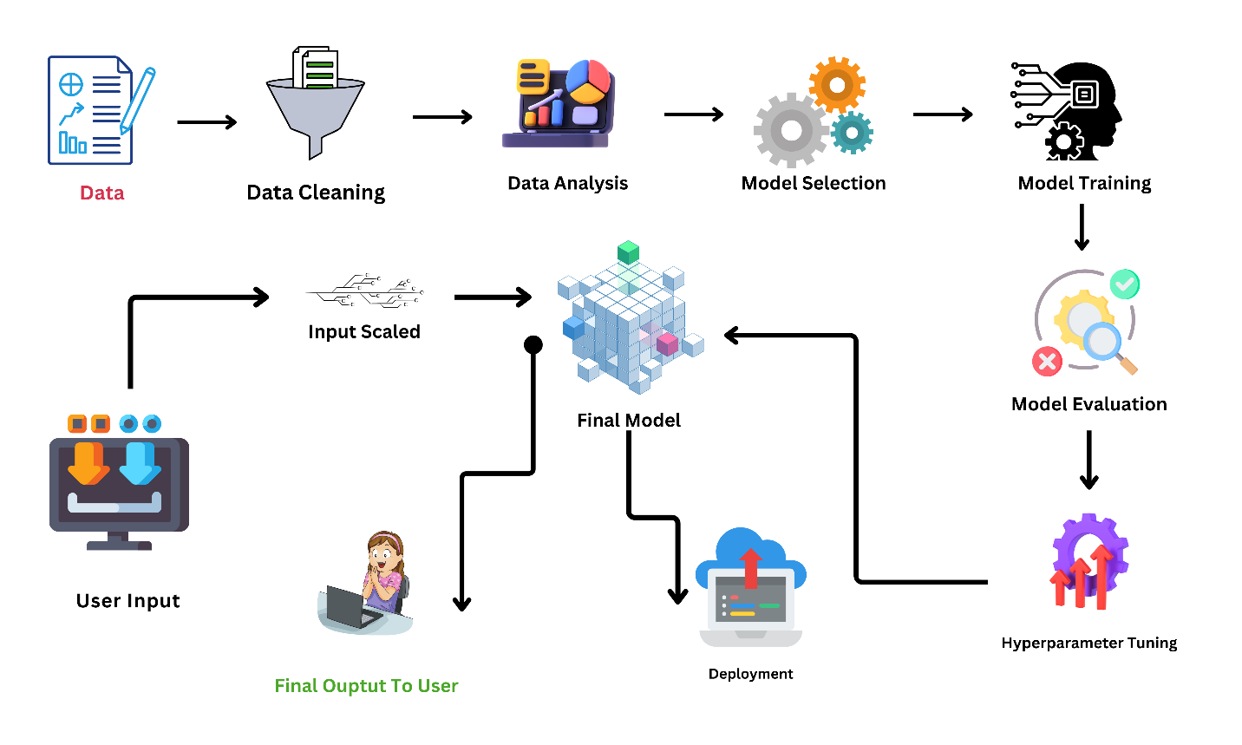

Proposed Solution:

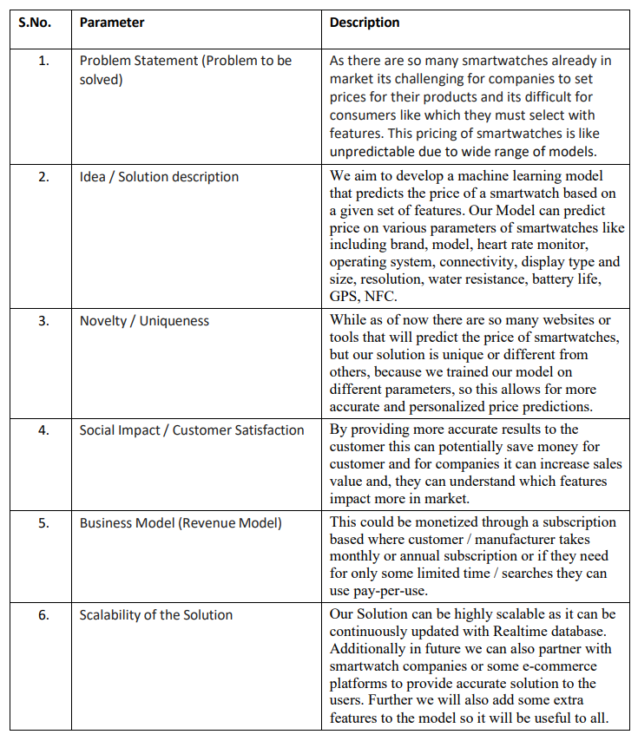

**6. PROJECT PLANNING & SCHEDULING**

**6.1 Technical Architecture**

Technical architecture, also known as system architecture or software architecture, refers to the high-level structure and organization of a software or information technology system. It encompasses the design and arrangement of components, modules, and services within a system to fulfill specific functional and non-functional requirements. Technical architecture serves as a blueprint for the development, deployment, and maintenance of a software solution.

1. Components

2. Modules

3. Data Management

4. Communication

5. Technology Stack

6. Deployment Architecture

7. Scalability

8. Security

9. Performance

10. Reliability and Fault Tolerance

11. Maintainability

12. Interoperability

Components & Technologies:

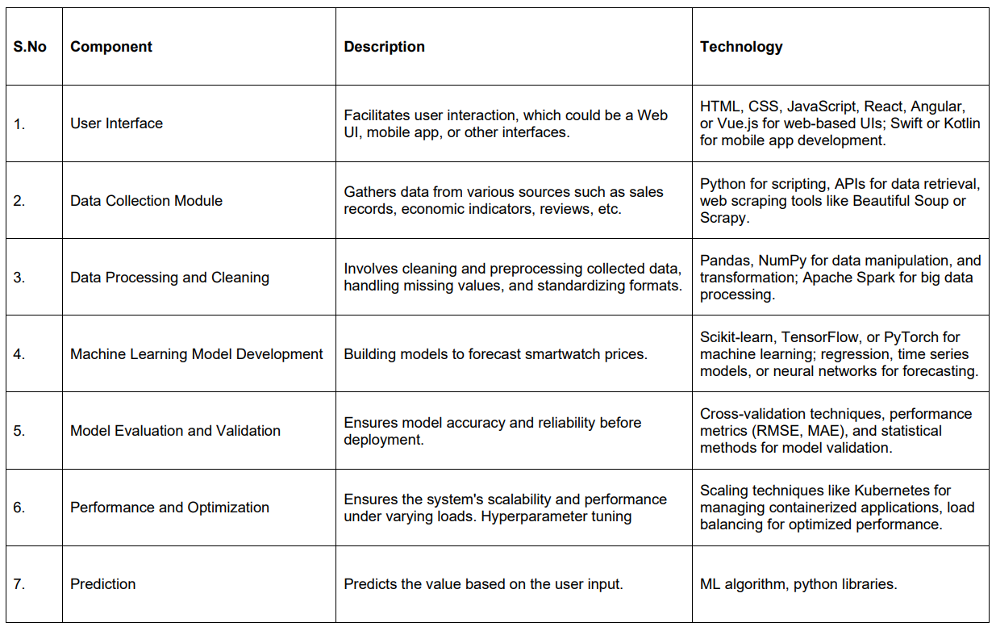

Application Characteristics:

**6.2 Sprint Planning & Estimation**

Sprint planning is a well-known term in the Agile software development methodology. Sprint planning is a regular event in Scrum, one of the Agile frameworks, where the development team and the product owner collaborate to plan the work to be done in the upcoming sprint.

Estimation:

**6.3 Sprint Delivery Schedule**

In Scrum, a sprint is a time-boxed iteration during which a potentially shippable product increment is created. Sprints are usually two to four weeks long, and they provide a consistent, short timeframe for development teams to deliver incremental value to the product.

BurnDown Chart:

A Burndown Chart is a visual representation of the progress of work completed versus the work remaining over time in a project. It is commonly used in Agile and Scrum methodologies to track the completion of tasks or user stories during a sprint or the entire project timeline. The chart provides a clear and easily understandable way to see how much work is left to be done and whether the team is on track to complete it within the specified time.

**7.CODING & SOLUTIONING**

**7.1 Feature 1**

**7.2 Feature 2**

**7.3 Database schema**

**8.PERFORMANCE TESTING**

**8.1 Perfromance Metrics**

**9. RESULTS**

**9.1 Output Screenshots**

**10. ADVANTAGES & DISADVANTAGES**

**Advantages:**

1. Informed Decision-Making:

- Insight: Users, manufacturers, and investors can make informed decisions based on predicted smartwatch prices, optimizing purchasing, production, and investment strategies.

2. Competitive Positioning:

- Insight: Smartwatch brands can strategically position themselves in the market by aligning prices with predicted trends, gaining a competitive edge.

3. Market Efficiency:

- Insight: Predictive modeling contributes to market efficiency by reducing price volatility, providing stability for both consumers and manufacturers.

4. Optimized Inventory Management:

- Insight: Manufacturers can optimize inventory levels based on predicted demand, reducing excess stock and minimizing storage costs.

5. Trend Analysis:

- Insight: Continuous price predictions offer insights into evolving market trends, helping stakeholders anticipate shifts in consumer preferences and technological advancements.

6. Enhanced Customer Experience:

- Insight: Consumers benefit from more stable and transparent pricing, making it easier to plan purchases and fostering trust in the smartwatch market.

7. Strategic Marketing:

- Insight: Brands can use price forecasts to develop strategic marketing campaigns, aligning promotions with expected market dynamics.

**Disadvantages:**

1. Data Limitations:

- Challenge: The accuracy of predictions relies heavily on the quality and completeness of historical data, and gaps or biases in the dataset can impact the model's reliability.

2. Algorithm Complexity:

- Challenge: Complex machine learning algorithms may be challenging to interpret, making it difficult to understand how specific factors influence price predictions.

3. Dynamic Market Factors:

- Challenge: Rapidly changing market conditions, such as technological advancements and unforeseen events, may challenge the model's ability to accurately predict prices.

4. Overreliance on Historical Patterns:

- Challenge: The model may be overly influenced by historical patterns, and unexpected market shifts or disruptions may not be adequately captured.

5. Ethical Considerations:

- Challenge: Predicting prices may raise ethical concerns, particularly if the model inadvertently perpetuates biases or negatively impacts certain market segments.

6. Resource Intensive:

- Challenge: Developing and maintaining a sophisticated predictive model can be resource-intensive, requiring skilled data scientists, ongoing updates, and computational resources.

7. User Adoption:

- Challenge: Stakeholders may resist adopting predicted prices, particularly if they deviate significantly from conventional pricing strategies, requiring effective change management.

It's important to note that the success of the project and the realization of these advantages depend on factors such as data quality, model accuracy, and the adaptability of the market to predictive pricing. Additionally, continuous monitoring and adjustments are crucial to address emerging challenges and ensure the sustained effectiveness of the predictive model.

**11.CONCLUSION**

In conclusion, the "Horology 2.0: Forecasting the Future of Smartwatch Prices using Machine Learning" project presents a promising venture with both notable advantages and challenges. The project, by leveraging predictive modeling, offers stakeholders valuable insights into smartwatch pricing dynamics, enabling informed decision-making, competitive positioning, and optimized inventory management.

The advantages, including enhanced customer experiences, strategic marketing opportunities, and market efficiency, underscore the potential positive impact on the smartwatch industry. However, the project is not without its challenges. Data limitations, algorithm complexity, and the dynamic nature of market factors pose significant hurdles that require careful consideration and mitigation strategies.

To navigate these challenges successfully, a robust approach to data collection, preprocessing, and model development is essential. Continuous monitoring, updates, and ethical considerations are critical components of ensuring the accuracy, reliability, and fairness of the predictive model.

Ultimately, the success of the project will hinge on its ability to adapt to evolving market conditions, address ethical concerns, and secure user adoption. With proper management and a commitment to addressing challenges as they arise, the "Horology 2.0" project has the potential to contribute positively to the smartwatch industry, fostering innovation, efficiency, and improved decision-making for all stakeholders involved.

**12.FUTURE SCOPE**

Certainly, here are the future scopes for the "Horology 2.0: Forecasting the Future of Smartwatch Prices using Machine Learning" project without bold formatting:

1. Integration of Real-Time Data:

- Explore the integration of real-time data sources to enhance the accuracy and responsiveness of price predictions. This could involve incorporating live market data, consumer sentiment analysis, and emerging technological trends.

2. Personalized Price Predictions:

- Develop algorithms that consider individual user preferences, behaviors, and demographics to provide personalized smartwatch price predictions. This could lead to a more tailored and engaging user experience.

3. Expanded Feature Set:

- Expand the feature set used for predictions to include a broader range of factors such as economic indicators, social trends, and geopolitical events. This would result in a more comprehensive and robust predictive model.

4. Cross-Device Compatibility:

- Extend the predictive model to cover a broader spectrum of wearable devices, including fitness trackers, smart glasses, and other emerging wearable technologies. This expansion could provide a holistic view of the entire wearable tech market.

5. Global Market Analysis:

- Scale the project to offer insights into global smartwatch markets, considering regional variations in consumer preferences, economic conditions, and cultural influences. This could support international businesses in making data-driven decisions.

6. Enhanced User Interfaces:

- Develop more intuitive and user-friendly interfaces for accessing and interpreting price predictions. Visualization tools, trend analyses, and user-centric dashboards could further engage users and stakeholders.

7. Predictive Analytics for Accessories:

- Extend the project's scope to include predictive analytics for smartwatch accessories, such as bands, chargers, and other peripherals. This would provide a more comprehensive solution for manufacturers and retailers.

8. Collaboration with Manufacturers:

- Establish partnerships with smartwatch manufacturers to integrate the predictive model into their pricing strategies. This collaborative approach could lead to mutually beneficial outcomes and improved market responsiveness.

9. Continuous Model Optimization:

- Implement mechanisms for continuous model optimization based on user feedback, market shifts, and technological advancements. Regular updates and refinements will ensure the model's relevance in the ever-evolving smartwatch industry.

10. Blockchain Integration for Transparency:

- Explore the integration of blockchain technology to enhance transparency in data collection, ensuring the integrity of historical data and fostering trust among users, manufacturers, and other stakeholders.

11. Market Impact Assessments:

- Extend the project to include assessments of the potential impact of price changes on the market, consumer behavior, and industry trends. This proactive analysis could guide stakeholders in making strategic decisions.

12. Predictive Maintenance for Devices:

- Investigate the application of predictive modeling beyond pricing, such as predicting maintenance needs for smartwatches. This could enhance the overall lifecycle management of devices.

These future scopes demonstrate the potential for ongoing innovation and development in the realm of smartwatch pricing prediction. As technology advances and user needs evolve, the project can evolve to meet the dynamic challenges and opportunities in the wearable tech market.

**13.APPENDIX**

**Source Code**

**Github & Project Demo Link**